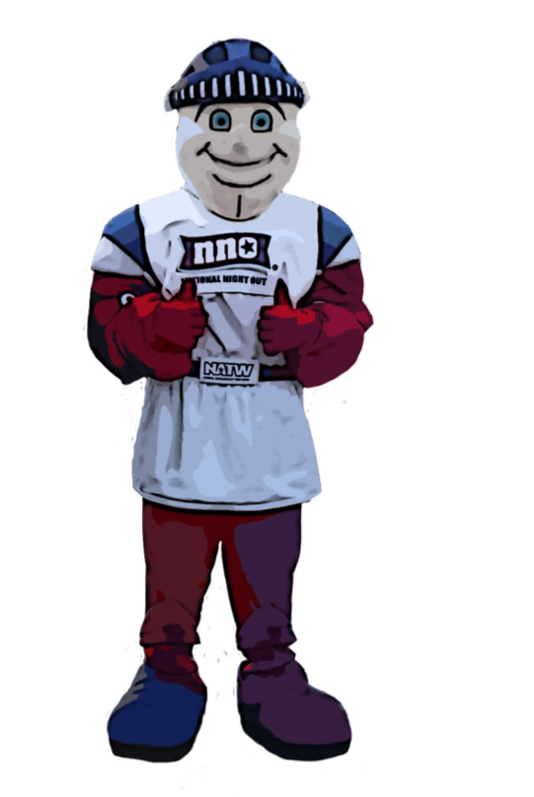
Date: Tuesday, August 6, 2019
Time: 6 pm – 9 pm
Place:
Theme/Event:
To RSVP, or Help out,
please call:
Name here at 777-7777, or
Name here at 777-7777.

